EXPT NO:6 | IMPLEMENTATION OF MULTIVARIATE DISPLAYS
DATE: 24.01.2026 | IMPLEMENTATION OF MULTIVARIATE DISPLAYS

PRE-LAB QUESTIONS

- Why are multivariate displays important in AI analytics?

Multivariate displays allow simultaneous visualization of multiple variables, helping AI analysts understand complex relationships, dependencies, and patterns that cannot be captured using univariate or bivariate plots. This is crucial in AI analytics where models rely on interactions between several features.

- How do parallel coordinates differ from scatter plots?

Scatter plots visualize relationships between two variables at a time, while parallel coordinates represent multiple variables simultaneously using parallel axes. Parallel coordinates are better suited for high-dimensional data exploration in AI workflows.

- What challenges exist in interpreting multivariate plots?

Challenges include visual clutter, overlapping data points, difficulty in identifying clear patterns, and increased cognitive load. Proper scaling, filtering, and interactive features are often required to improve interpretability.

- Where are trellis displays commonly used?

Trellis displays are commonly used in exploratory data analysis to compare patterns across different subsets of data, such as categories, groups, or time periods. They are widely used in statistical analysis and AI feature comparison.

- How does multivariate visualization aid model evaluation?

Multivariate visualization helps assess feature interactions, detect anomalies, and compare model predictions against multiple input variables. This supports better evaluation of model behaviour, performance, and potential biases.

IN-LAB EXERCISE:

OBJECTIVE:

To implement advanced multivariate displays for complex data analysis.

SCENARIO:

A retail analytics firm studies sales, profit, customer segment, and region to optimize business strategy.

IN-LAB TASKS (Using R Language):

• Create parallel coordinate plots
• Generate bubble charts
• Implement trellis displays by region

Code:

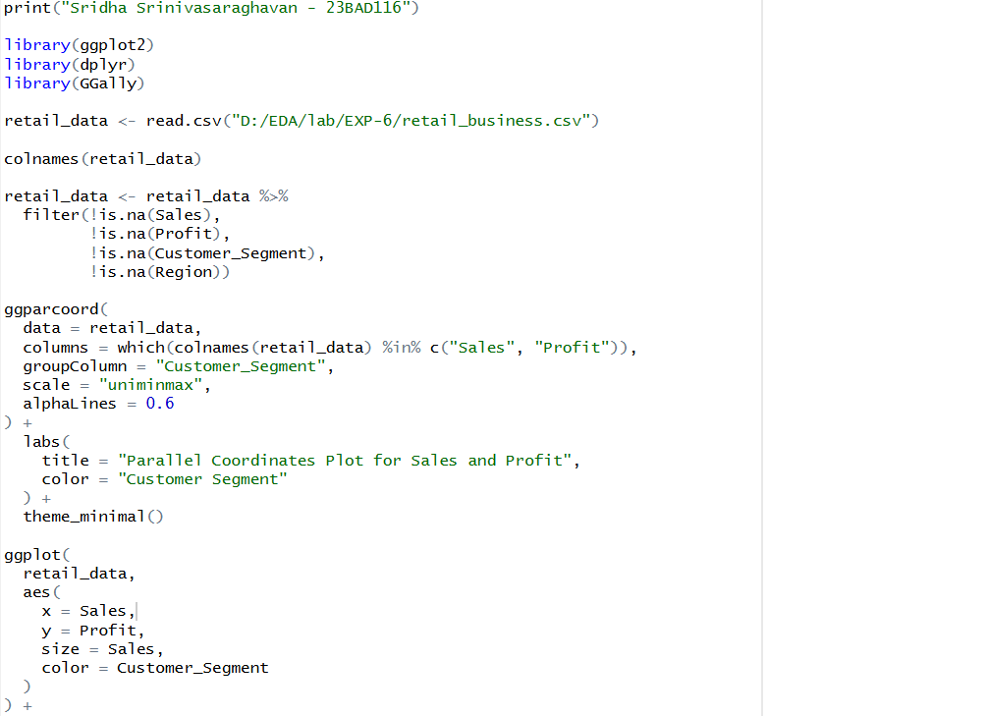
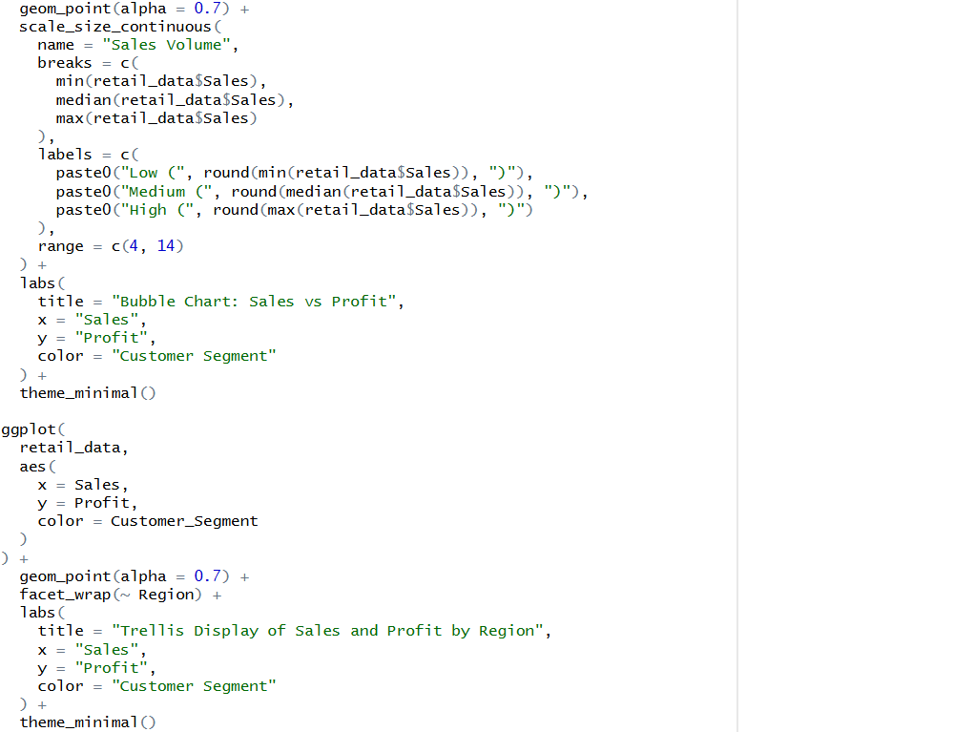
Output:

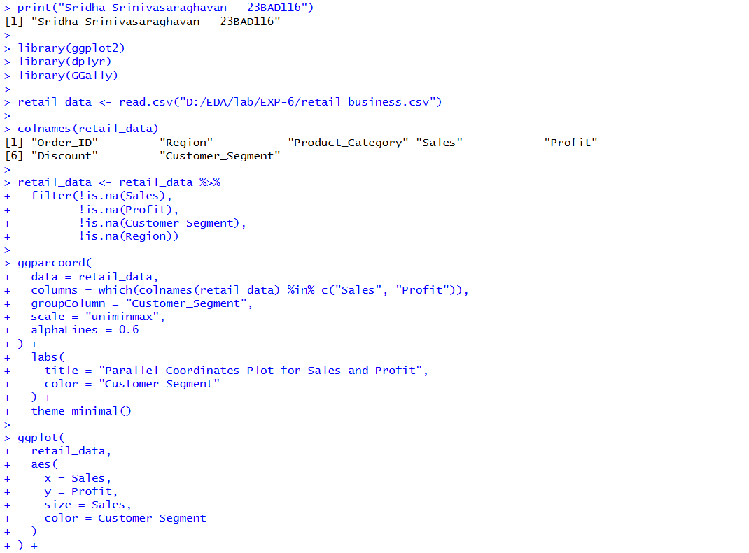
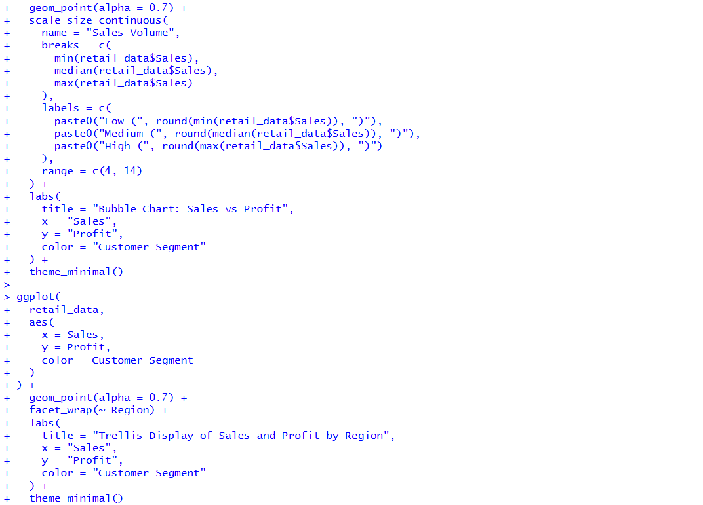

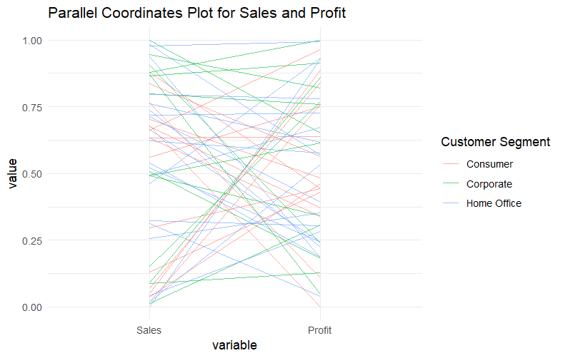

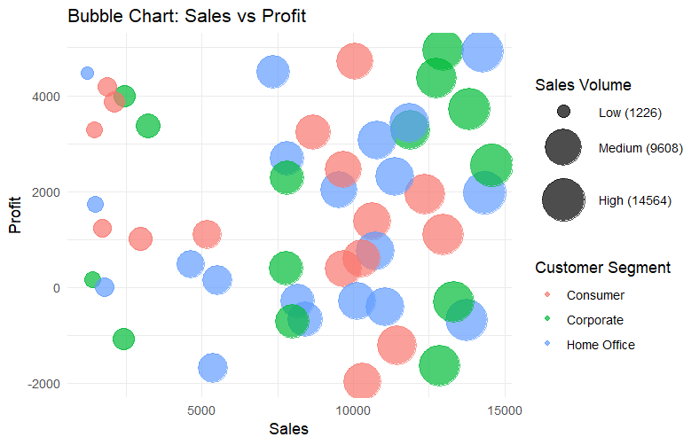

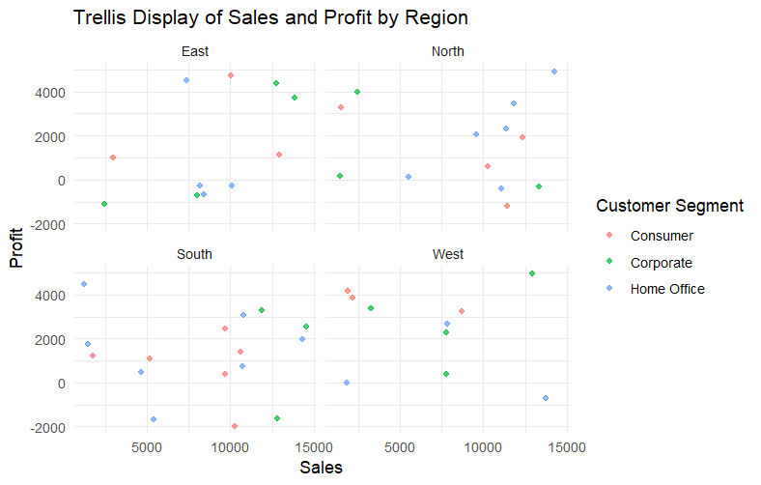

POST-LAB QUESTIONS

- What insights are gained from parallel coordinates?

Parallel coordinate plots allow simultaneous visualization of multiple numerical variables, helping identify patterns, correlations, clusters, and outliers across high-dimensional data. They reveal how variables interact and where values increase or decrease together.

- How does faceting simplify complex data?

Faceting divides data into multiple smaller plots based on categories, enabling side-by-side comparison of patterns across groups. This reduces visual clutter and improves interpretability in complex datasets.

- What limitations exist in bubble charts?

Bubble charts can suffer from overlap, difficulty in comparing bubble sizes accurately, and misinterpretation when too many data points are present. They are less effective for precise quantitative analysis.

- How can these display support AI-driven recommendations?

These visualizations help analysts understand feature relationships and performance trends, which informs feature selection, model tuning, and generation of explainable AI-driven recommendations.

- Suggest improvements for large multivariate datasets.

Apply dimensionality reduction techniques, interactive filtering, aggregation, and sampling to reduce complexity while preserving important patterns for clearer visualization.

LEARNING OUTCOME: Students apply multivariate visualization for business intelligence.

ASSESSMENT
Description | Max Marks | Marks Awarded
Pre Lab Exercise | 5
In Lab Exercise | 10
Post Lab Exercise | 5
Viva | 10
Total | 30
Faculty Signature

